# TYPE-2 HYPERVISOR WITH A HOST OPERATING SYSTEM AS LINUX

**STEP – 1:**

Create a virtual machine using virtual box.

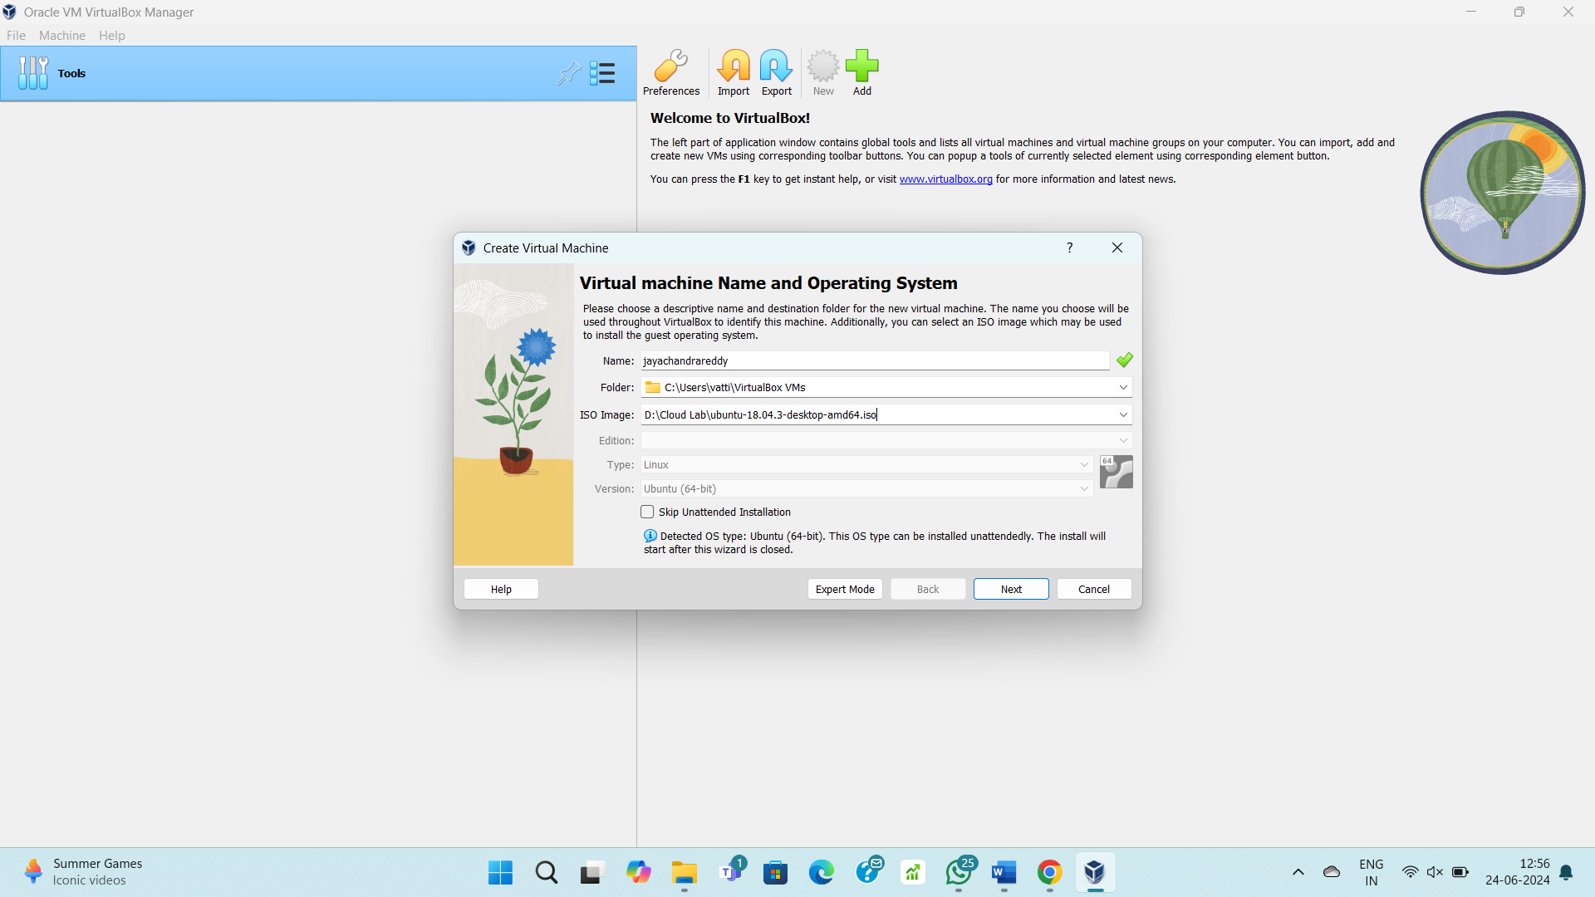

**STEP – 2:**

Give credentials for user login.

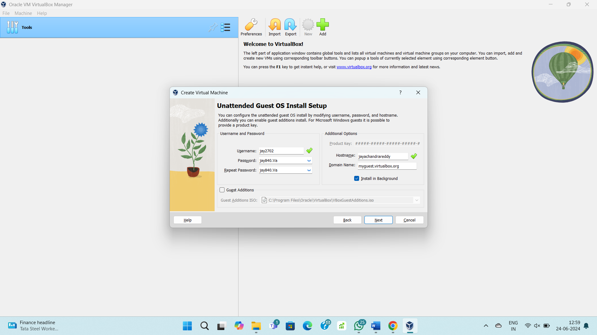

**STEP – 3:**

Allocate resources to the VM.

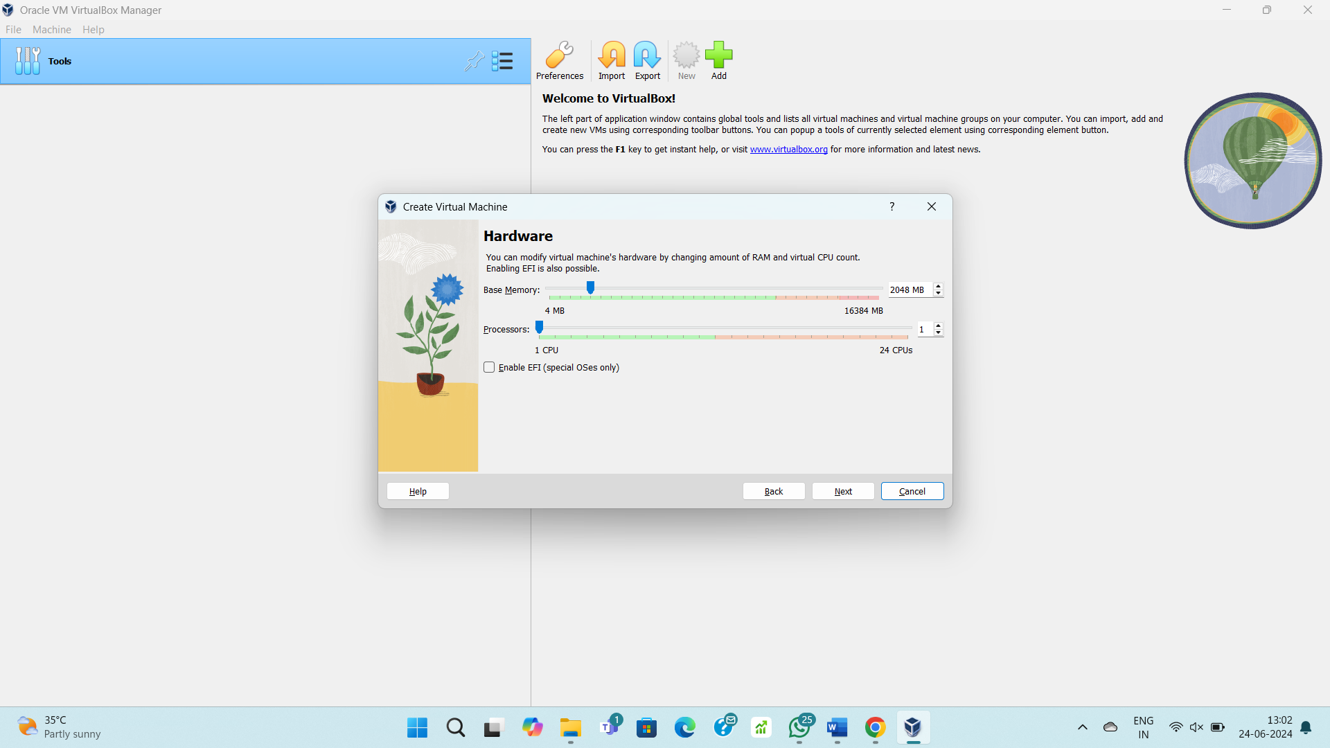

**STEP – 4:**

Allocate disk storage to the VM.

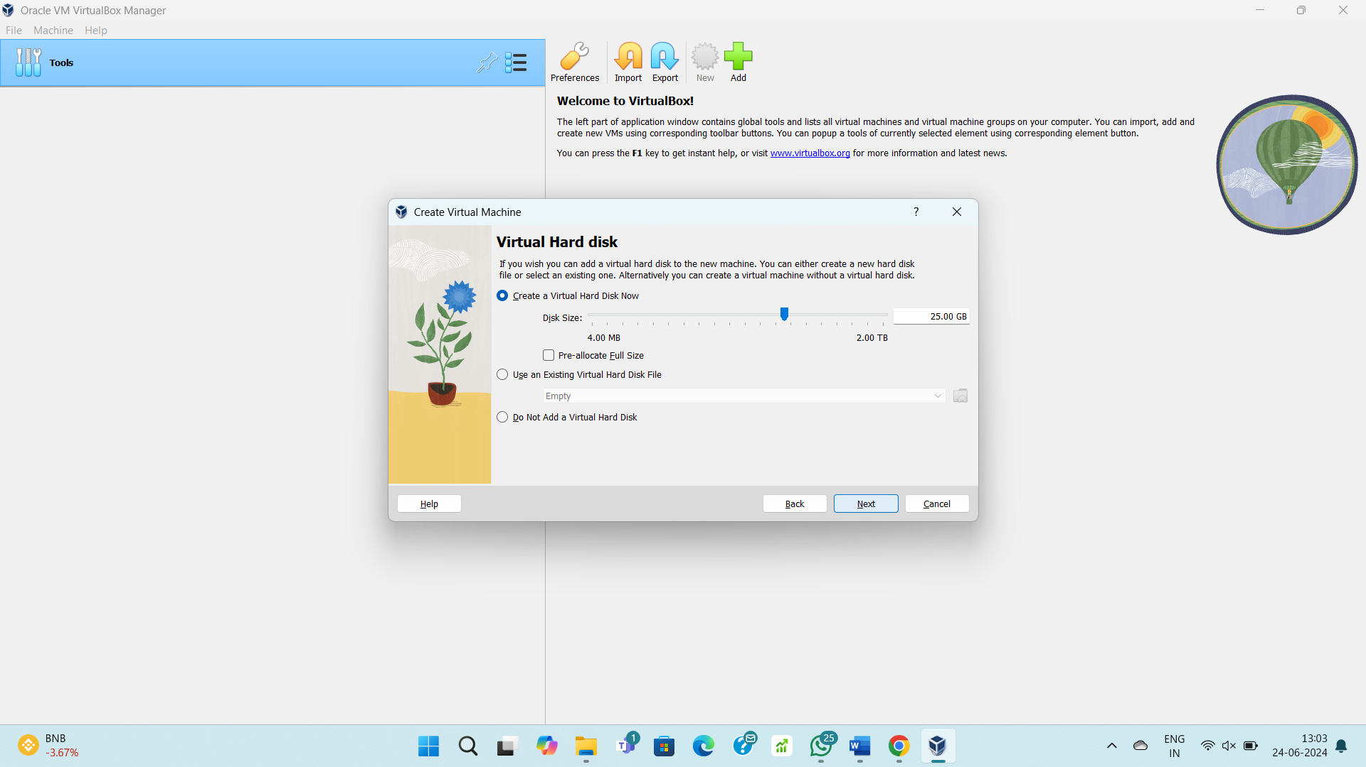

**STEP – 5:**

Created a new OS.

